# PhpStorm Installation Guide

This document is a walkthrough through the process of **installing PhpStorm.**

This lab is part of the [“Technology Fundamentals” course @ SoftUni](https://softuni.bg/courses/technology-fundamentals).

# Installing PhpStorm

This first part will show you how to **install PhpStorm**.

## Downloading PhpStorm

Download **PhpStorm** version 2018.2.3 from [this LINK](https://www.jetbrains.com/phpstorm/download) for you operating system (Windows, macOS, Linux)

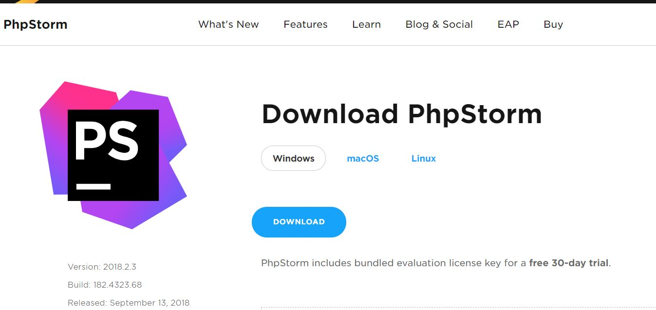

## Installing PhpStorm

Run the **PhpStorm-*.exe** and follow the instructions in the installation wizard.

